TASK 5 :
1. TTS (Text To Speech) :
It converts normal text into Speech.
This tech enables the system to speak out the text in a human voice.
It has 3 steps
Step1 - pre-processing or normalization: conversion of the symbols, numbers and abbreviations into words. like ‘?’ will be converted into “question mark”.
Step2 - conversion of normalized text into phonemes or phonetic transcripts: The phonemes are the small parts of spoken words i.e. these are the sounds that make sentences. It is essential so that the machine can speak the words as humans do.
Step3 - synthesis of phonemes into spoken voice
#Programming for TTS (Text To Speech) :
For TTS programming in Arduino ide we should install Talkie library.
Some header files are used:
Talkie.h is used to initialize this library
Vocab_US_Large.h is used to use the alerts.
Vocab_Special.h is used to use the pause.
2. HAND TALK HAND GLOVE
It is a small project in which I made a smart glove. when a person wear that glove in his hand and bend his fingers the machine read his sign and display in LCD what he want . and also speak through speaker.
Required Components
-nodemcu esp8266 (1)
- flex sensors (4)
- 16x2 LCD Display with I2C (1)
- A speaker with IC LM386 audio amplifier (1)
- couple of jumper wires
Circuit Diagram -

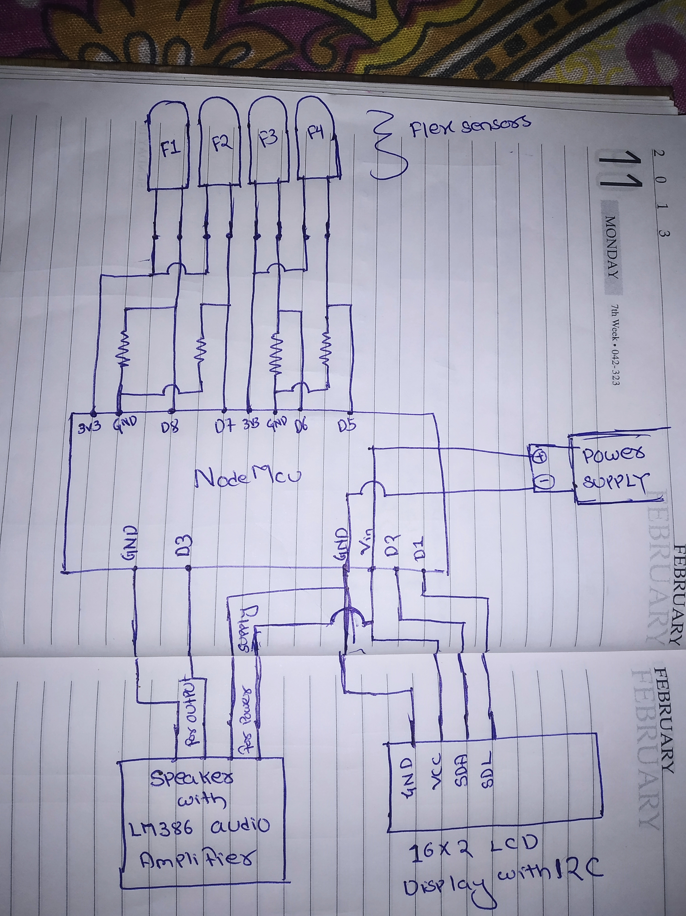
Explanation of circuit diagram:
1st we used 4 flex sensors named as F1, F2, F3, F3 are connected to pin of nodemcu D8, D7, D6, D5 respectively. It gives us input
And for output, I connect a 16x2 LCD Display with I2C to nodemcu pin D1 & D2
and a speaker with LM386 Audio Amplifier.
(The I2C communication is one out of three possible communication protocols, the Arduino / ESP8266 is able to communicate with other devices like OLED displays, barometric pressure sensors and so on.)
(LM386 is a low voltage audio amplifier. The gain range is 20 to 200 simply means that Voltage out is 200 times the Voltage IN. LM386 has a wide supply voltage range 4-12v. )
Code for the project :
#include "Wire.h"
#include "LiquidCrystal_I2C.h"
#include "Talkie.h"
#include "Vocab_US_Large.h"
#include "Vocab_Special.h"
const int flexPin1 = 15;
const int flexPin2 = 13;
const int flexPin3 = 12;
const int flexPin4 = 14;
Talkie voice;
void setup()
{
lcd.init();
lcd.backlight();
lcd.clear();
}
void loop()
{
int flexValue1;
flexValue1 = analogRead(flexPin1);
int flexValue2;
flexValue2 = analogRead(flexPin2);
int flexValue3;
flexValue3 = analogRead(flexPin3);
int flexValue4;
flexValue4 = analogRead(flexPin4);
f1=flexValue1;
f2=flexValue2;
f3=flexValue3;
f4=flexValue4;
while(f1 > 890)
{
lcd.clear();
lcd.setCursor(0,1);
lcd.print("Water");
voice.say(spPAUSE2);
voice.say(sp2_WATER);
voice.say(sp2_WATER);
f1=flexValue1;
}
while(f2 > 890)
{
lcd.clear();
lcd.setCursor(0,1);
lcd.print("Tea");
voice.say(spPAUSE2);
voice.say(sp2_TEA);
voice.say(sp2_TEA);
f2=flexValue2;
}
while(f3 > 890)
{
lcd.clear();
lcd.setCursor(0,1);
lcd.print("Coffee");
voice.say(spPAUSE2);
voice.say(sp2_COFFEE);
voice.say(sp2_COFFEE);
f3=flexValue3;
}
while(f4 > 890)
{
lcd.clear();
lcd.setCursor(0,1);
lcd.print("Lunch");
voice.say(spPAUSE2);
voice.say(sp2_LUNCH);
voice.say(sp2_LUNCH);
f4=flexValue4;
}
while(f1 > 890 && f2 > 890 && f3 < 890 && f4 < 890)
{
lcd.clear();
lcd.setCursor(0,1);
lcd.print("Dinner");
voice.say(spPAUSE2);
voice.say(sp2_DINNER);
voice.say(sp2_DINNER);
f1=flexValue1;
f2=flexValue2;
f3=flexValue3;
f4=flexValue4;
}
while(f1 < 890 && f2 < 890 && f3 > 890 && f4 > 890)
{
lcd.clear();
lcd.setCursor(0,1);
lcd.print("Breakfast");
voice.say(spPAUSE2);
voice.say(sp2_BREAK);
voice.say(sp2_FAST);
f1=flexValue1;
f2=flexValue2;
f3=flexValue3;
f4=flexValue4;
}
delay(20);
}
WORKING :
1St a person wear the hand glove in which the flex sensors are fixed on 4 fingers of that glove except thumb.
When that person bends his 1st finger the value of F1 will increase from 890 and in LCD display. "Water" and in speaker sound water for 2 times.
Similarly when 2nd finger bends it displays "Tea" and spoke "Tea" for 2 times
Similarly For 3rd finger - coffee
for 4th finger - Lunch
If 1st & 2nd finger bends at the same time it displays "Dinner" and speak "Dinner"
If 3rd & 4th finger bends at the same time it displays "Break Fast" and speak"Break Fast"

BIBLIOGRAPHY :
https://circuitdigest.com/microcontroller-projects/arduino-based-text-to-speech-converter
https://diyi0t.com/lcd-display-tutorial-for-arduino-and-esp8266/
https://circuitdigest.com/electronic-circuits/lm386-audio-amplifier-circuit
https://youtu.be/vm0Ep_lf9Dg
https://youtu.be/xQaRHk9H0-k
https://youtu.be/Hu9hXhJ-9gA
https://youtu.be/jaQtbtvFsOo

